

AUTHORIZATION AGREEMENT FOR AUTOMATIC PAYMENTS
(ACH CREDITS)

Company Name: Landmark Healthplan of California, Inc.

Federal Tax I.D. Number: 68-0352158

Address: 1610 Arden Way, Suite 280, Sacramento, California 95815

Contact Person: Gail Zinn, Accountant
Telephone Number: (502) 897-8744 Fax Number: (502) 897.5159

We hereby authorize (Company Name) wherein after called Company, to initiate credits entries to our account indicated below and the depository named below, hereinafter called Depository, to credit the same such account.

Depository Name: PNC Bank

Address: 3828 Shelbyville Road, Louisville, KY 40207

Contact Person: Jenna Smith

Telephone Number: (502) 212-6281 Fax Number: (502) 899-9765

Transit Routing Number: 083000108

Account Name: Landmark Healthplan of California, Inc

Account Number: 3032419942

The effective date of this change is December 15,2015 . This authority is to remain in effect until Company has received written notification from us of its termination in such time and such manner as to afford Company and Depository a reasonable opportunity to act on it.

Authorized Signature: Authorized Signature:
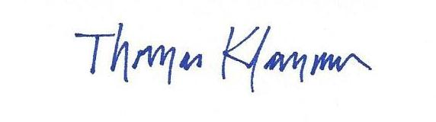

Name: Tom Klammer Name:
Title: CFO Title:
Date: December 15, 2015 Date:

